Market Segmentation

Hemanth konduru

2nd may 2024

Gitlink: <https://github.com/Hemanth-konduru/Market-Segmentation-on-EV-market-for-startups.git>

1 Market segmentation

Since the Indian market for electric vehicles is still in its infancy, few data are available to give insight into the country's electric vehicle user base. Therefore, we modified our strategy and began gathering customer data from currently registered fuel-powered automobiles. We then used this data to do basic behavioral and demographic analysis in an effort to better understand the market. The next step in the geographic analysis is to determine which region is most likely to be a good market for which kind of electric vehicle by using some state-level statistics.

Following this study, we may divide the market based on the salient features of the intended audience using model-based algorithms.

* 1. Behavioral And Psychographic Analysis

Customer segmentation based on patterns of behavior shown by consumers when they engage with a business or brand or make a purchase is known as behavioral segmentation. It enables companies to categorize their clientele based on factors like product, service, or brand knowledge, attitudes, usage, or reactions. A consumer's lifestyle, interests, and opinions must be understood in order to apply the psychographic segmentation strategy. Because a consumer's purchasing activity reflects their lifestyle, hobbies, and beliefs, we have merged the two sorts of study.

The dataset we used is a survey of owners of specific brands of fuel-powered automobiles. It includes some basic characteristics like age, salary, marital status, loan status, number of dependents, education, and occupation, as well as the make and price of the car.

2 Observations:

Age: Younger buyers tend to buy less expensive cars. This can be explained by the fact that they are unmarried, have fewer dependents, and have less money, which eliminates the necessity and opportunity to purchase more expensive cars.

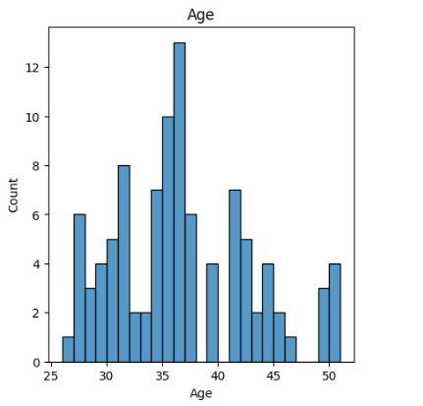

The No.of dependents: When a consumer has more dependents, they tend to purchase SUVs or other vehicles with more seats.

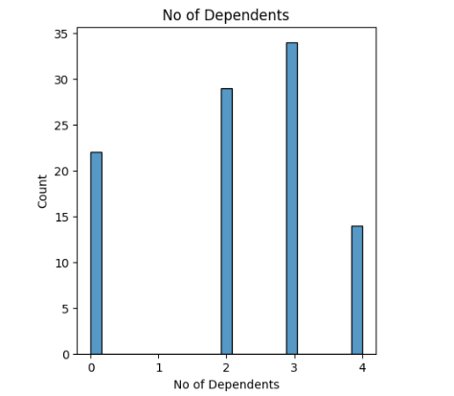

Salary: When you compare the price and normalized salary plots, you will see that there is a strong correlation between the two. This makes sense because most individuals only purchase cars they can afford. The median wage plot fits the price of the vehicle.

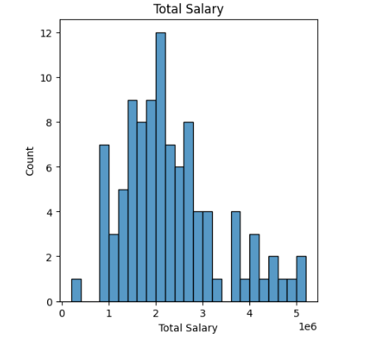

Price of the vehicle: This data point presents the price of the current vehicle owned. This provides us with the info of what price range a customer might spend.

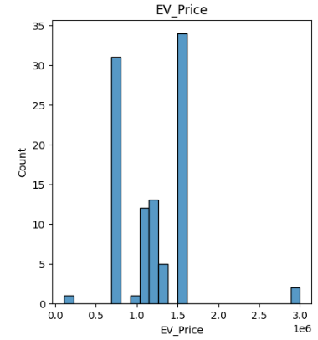

3 Approaches Used for Segmentation

We are employing a population behavioral research to undertake market segmentation, in which 100 participants are chosen at random from the total population, and information pertinent to our objective—that is, the ability to purchase an automobile—is recorded. We shall divide the market into different segments since we are attempting to identify the best target segment for market penetration. Classification can be done in two main ways: data-driven classification and classification using common sense. Here, we'll be using K-Means Clustering, a data-driven categorization technique.

3.1 Algorithm : K-Means Clustering

Unsupervised learning techniques like K-means clustering are used to unlabelled data, or data that lacks clear classifications or groups. This algorithm's objective is to identify groups within the data, with the variable K denoting the number of groups. Using the given features, the algorithm iteratively assigns each data point to one of K groups. The similarity of features is used to cluster data points. The K-means clustering algorithm's findings are:

1. The K cluster centroids, which are useful for labelling fresh data.

2. Training data labels (each data point belongs to a separate cluster)

In a K-means analysis, the term "means" denotes the process of averaging the data, or locating the centre.

The K-Means Clustering follows these steps:

1. Indicate how many segments you want there to be.

2. From data set X, choose k observations (consumers) at random to serve as the first set of cluster centroids, C = {c1,..., ck}.

3. To divide the data into k market segments S1,..., Sk, assign each observation xi to the nearest cluster centroid. This indicates that a representative from the beginning segment is allocated to each consumer in the data collection. In order to do this, the distance between each customer and each segment representation is calculated, and the consumer is then placed in the market segment with the representative who is the most like them.

4. Recalculate the cluster centroids (segment representatives) by minimizing the distance between each consumer and the corresponding cluster centroid while maintaining a fixed cluster membership.

Step 3 should be repeated until convergence is achieved or a predetermined maximum number of iterations is reached. At this point, the partitioning algorithm's stepwise procedure comes to an end, and the segmentation solution is deemed to be the best one.

3.2 Libraries Used :

NumPy : Scientific Computing Library

Pandas : Data Analysis Library (mainly used to manage data frames)

Matplotlib : Data Visualization Library

seaborn : Data Visualization Library

Plotly : Data Visualization library

Kmodes : A K-means clustering library

Mpl toolkit : 3D Graphs

3.2 Implementation

Data Sources: We used Indian consumers' car-purchasing habits as our dataset. We will be able to identify several characteristics linked to purchasing behaviors with this dataset.

Preparing Data: We now search the dataset for any null items that may exist after correctly classifying it. There aren't any such entries in our situation.

Model Deployment: Using the Elbow Method, we first seek to determine the ideal K value by locating the Within Cluster Sum of Square (WCSS) and attempting to identify the point at which it rapidly declines, giving the graph the appearance of a "elbow" at that location. The ideal K value is the one that corresponds to that point.

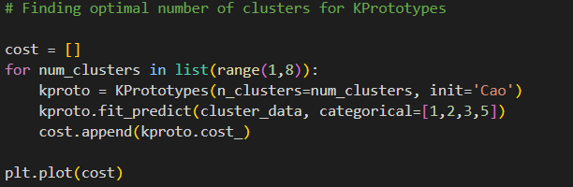

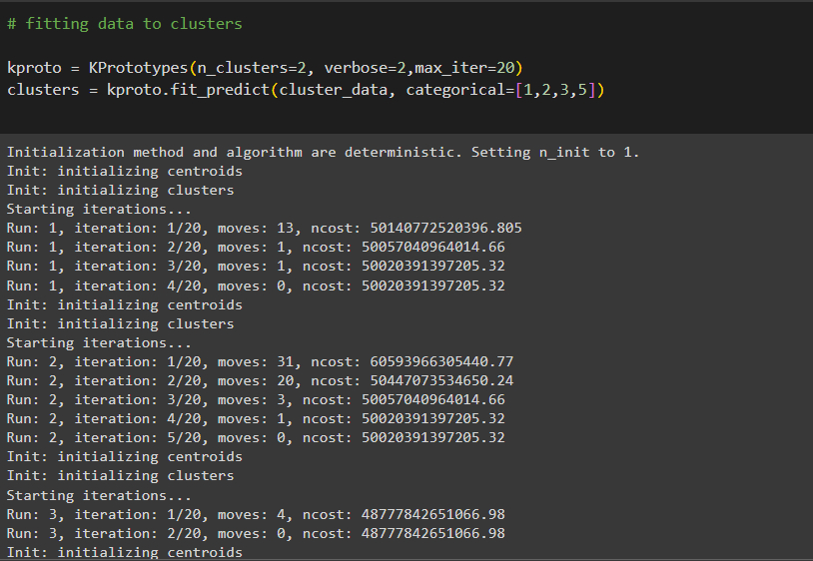

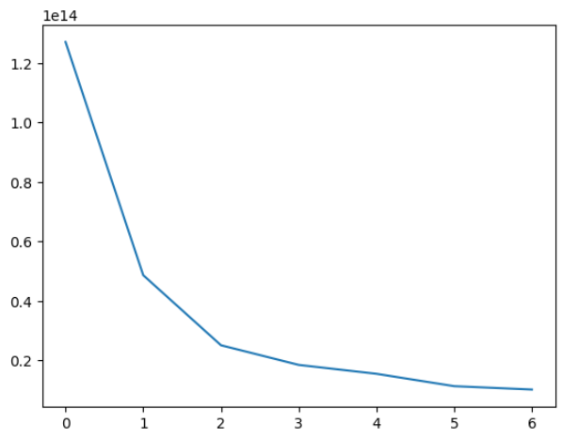

3.3 Target Segment

Younger people are more likely to buy products with new technology, particularly electric vehicles, because they understand the environmental benefits and want to see that change. However, our research revealed that younger people also tend to buy less expensive vehicles, which can make electric vehicles less affordable. Next, it is advised to focus on a market segment that is both financially stable enough to purchase electric vehicles and still open to experimenting with new technology. These individuals most likely fall within the 25- to 40-year-old age range.

Individuals from metropolitan areas with access to infrastructure and education on technology and its advantages are more likely to buy electric cars. Married individuals with dependents are more likely to own a car, which makes them vulnerable to attack. The average income of those who acquire cars is about 30 lakh, with the majority of purchases falling between 10 and 20 lakh for cars and less for two-wheelers. These are other factors that must be considered.

3.4 Marketing Mix

Deciding how much to charge for our goods is a science and an art. The most crucial thing is to be aware of and comprehend your production costs. From there, you can modify in accordance with features of the product, a particular pricing plan, the price sensitivity of the consumer, the customer's values, and other elements. The marketing mix aids in planning a successful product offering by assisting in understanding what our product or service may give to our clients. aids in the formulation, planning, and implementation of successful marketing strategies. Assist in determining whether your service or product is appropriate for your clients.

3.5 Product

Given that EVs are still relatively new, a large number of people are adjusting to them, and there are numerous resources available to assist them, such as maintenance services for charging stations and other support, India would undoubtedly be a great market for an EV company to penetrate. The ideal product for a startup to grow quickly is one that costs between 8 and 20 lakhs. Since the primary target market is made up of people in their 25 to 40 age range, a modern design with flagship technology bundle will draw in more clients..

3.6 Price

Affordability is a major issue with the growth of Electric Vehicles. It is

important to keep in mind that in order to appeal to the consumers, the

company’s product has to be cost effective to both purchase and maintain. The

product’s price should ideally range between 10 to 20 lakh, as most people

would make a purchase in this range.

3.7 Place

Another crucial consideration that must be made while developing and releasing any product is infrastructure. The nation's largest cities ought to be the focus because that is where the infrastructure would be supported. The fact that educated people are more likely to live in metropolitan areas and be willing to purchase electric vehicles due to their awareness of the benefits to the environment is another reason to focus on these areas.

4 References

● https://www.researchgate.net/publication/325801124

● https://www.mordorintelligence.com/industry-reports/india-electric-v

ehicle-market

● https://samples.mordorintelligence.com/69655/Sample%20-%20India

%20Electric%20Vehicles%20Market%20(2020%20-%202025)%20-%

20Mordor%20Intelligence.pdf

● https://jmkresearch.com/registered-ev-sales-in-india-in-2020-dropped

-by-26-on-yoy-basis/

● https://jmkresearch.com/registered-ev-sales-drop-20-y-o-y-in-fy2021/

● https://www.siam.in/statistics.aspx?mpgid=8&pgidtrail=12

5 For Datasets

● https://electricvehicles.in/electric-vehicles-sales-report-in-india-2018/

● https://www.kaggle.com/karivedha/indian-consumers-cars-purchasing

-behaviour

● https://data.gov.in/

● <https://vahan.parivahan.gov.in/vahan4dashboard/vahan/view/report>

view.xhtml

● https://www.kaggle.com/datasets?search=+EV+market+data